Scouting Report - Luke Hetherington - Outfield

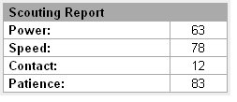
- Full Name: Luke James Hetherington
- Date of Birth: 4/13/1983
- Height: 6’1
- Weight: 205
- Bats: Right
- Throws: Right
- High School: Kentwood, Kent, Washington
- College: None
- Draft: 2001 Amateur Draft 9th round 271st overall by Toronto
- Current Team: Lake Erie Crushers (Frontier League)

Strength
- Great Leadership
- Above Average Speed
- Strong Work Ethic
- Great Closing Speed
- Smart Base Runner

Weakness
- Lacks Consistent Contact
- Average Fielding

