Emanuele Giardina

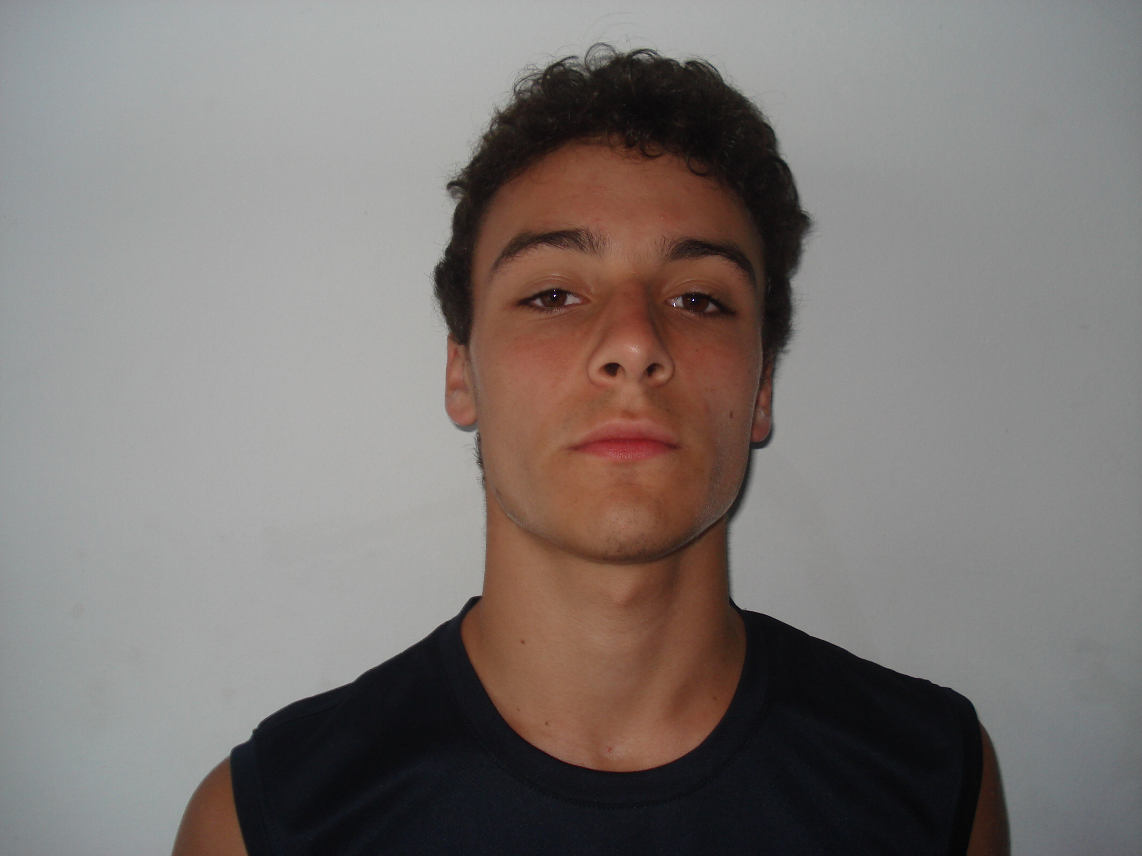

Age: 15 Born 11/01/1994
Position: Point Guard/ Wing
Height: 5’10 – Meters 166
Pounds: 147 – Kgs 67
Club: Italy Club Tradate
Right Hand
*Note All players that I evaluated at Camp Lignano Sabbaidoro are young and all have their weaknesses. Each of these players will only get better with good coaching and competition. These players will excel at a competitive High School Varsity level in the USA and have potential to play at the Collegiate level in the USA and Professional level in Italy.

Report

Tenacious point guard, quick and explosive can handle well with both hands. Never gets tired and has a strong body built which he uses to makeup for his size difference. Emanuele has good 3 point range and is capable of shooting of the dribble. His speed and court vision allows him to set up his teammates for open shots. Emanuele has the ability to penetrate the defense and dish. Needs to work on a runner / floater (tear drop) to help keep the defense honest. Great on ball defender (ball hawk) moves his feet well with great footwork. Emanuele is a great open court player and showed he can run an offense and wants the ball in his hand at the end of games. His youth sometimes shows needs to make better decision at full speed.

My grade; B+
Low Level Div 1 college basketball player
Division 2 / NAIA Impact player

