Tyler Toffoli:
NHL Prospect Profile/Scouting Report
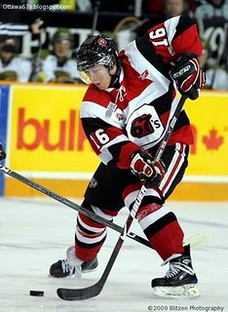
Photo courtesy of Blitzen Photography & Ottawa 67's Fan Blog
Team: Ottawa 67’s
League: Ontario Hockey League
Position: RW / C
Born: April 24, 1992
Hometown: Scarborough, ON
Height: 6.00
Weight: 180
Report Card (Excellent, Good, Average, Below Average, Poor)
Size/Strength Average
Skating Good
Shot/Scoring Excellent
Puckhandling Good
Physical Play Good
Offensive Play Excellent
Defensive Play Average
Hockey Sense Excellent
Competitiveness Excellent
Strengths
1. Hard, quick shot
2. Hockey sense
3. Being in the right place at the right time
Area’s For Improvement
1. Defensive game
2. Skating
Skill:
Dynamic offensive player maker who can find the net and has a great shot.
Scouting Report:
Toffoli got off to a very slow start this season but exploded offensively about a quarter-way through tallying almost 1.5 points per game. Toffoli is a smart offensive player who can contribute at both ends of the rink. While he is not the fastest skater, he is quick and is the type of player that is able to find open space easily. He sees the ice very well and is able to read and react to the play. Toffoli has great poise and patience with the pass, but sometimes opts to pass instead of shoot. He has a hard shot with a quick release that could be very valuable to him as quarterback on the powerplay. Despite his smaller frame, Toffoli is not afraid to go into the corners to fight for the puck or stand in front of the net and take the physical abuse. His average size is not so much the question, but rather if he it is enough to survive with bigger opponents. Toffoli is listed as both a centreman and a forward, but has played better on the wing.
Toffoli has often been criticized for not having any outstanding quality but also not having any glaring weaknesses. His biggest knock has been his skating; however, you can tell he has worked hard during the off-season and has improved drastically by the mid-way point of this season. His skating is quick rather than fast. Toffoli’s biggest strengths are his shot & hockey sense.
NHL Potential:
1st line or 2nd line forward
Style compares to:
Kyle Wellwood
Year | Team | GP | G | A | PTS | PIM
08/09 | Ottawa | 54 | 17 | 29 | 46 | 16
07/08 | Ottawa | 65 | 37 | 42 | 79 | 54

