DALTON SMITH:
NHL Prospect Profile/Scouting Report
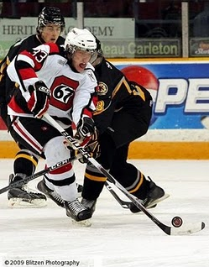
Photo courtesy of Blitzen Photography & Ottawa 67's Fan Blog

Team: Ottawa 67’s
League: Ontario Hockey League
Position: LW
Born: June 30, 1992
Hometown: Oshawa, ON
Height: 6.01
Weight: 195

Report Card (Excellent, Good, Average, Below Average, Poor)

Size/Strength Excellent

Skating Average
Shot/Scoring Good
Puckhandling Good

Physical Play Excellent
Offensive Play Good

Defensive Play Very good
Hockey Sense Excellent
Competitiveness Excellent

Strengths
1. Physical play
2. Work ethic
3. Leadership

Area’s For Improvement
1. Skating
2. Agility

Skill:
Feisty two-way player that is willing to sacrifice the body

Scouting Report:
Smith is a power forward that can set the tone of the game with a big hit or a big goal. He is strong on his skates and hard to knock off the puck. He has decent size and still has some room to fill out. Smith uses his size to his advantage. He has the ability to win battles in the corners and along the boards. Smith has great hands in close and is always around the crease looking for those dirty goals. He can contribute at both ends of the rink and complements his solid two-way play. Smith forechecks hard and hits effectively. He is willing to sacrifice the body to block a shot or make a good play. His skating has been a concern but is continuing to improve and his statue will excel if he can get quicker.

Smith had been playing on the top line for most of the season but with the return of a veteran player, he was dropped down to the third line. Smith’s point production started to decrease but everything else was still there. With his excellent work ethic and willingness to protect his teammates you can see the start of some strong leadership qualities. The bloodlines are also there as Dalton Smith is the son of former Buffalo Sabre, Derek Smith.

NHL Potential:
Power forward with skill to contribute offensively

Style compares to:
Milan Lucic

Year | Team | GP | G | A | PTS | PIM
09/10 | Ottawa | 62 | 21 | 23 | 44 | 129
08/09 | Ottawa | 17 | 2 | 5 | 7 | 8

