TY

RYAN MARTINDALE:
NHL Prospect Profile/Scouting Report
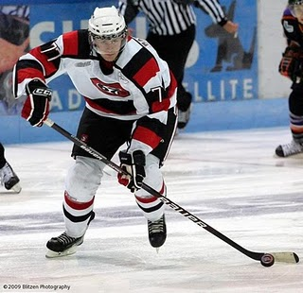
Photo courtesy of Blitzen Photography & Ottawa 67's Fan Blog

Team: Ottawa 67’s
League: Ontario Hockey League
Position: C
Born: October 27, 1991
Hometown: Brooklin, ON
Height: 6.03
Weight: 190

Report Card (Excellent, Good, Average, Below Average, Poor)

Size/Strength Excellent

Skating Good
Shot/Scoring Good
Puckhandling Good

Physical Play Good
Offensive Play Excellent

Defensive Play Good
Hockey Sense Excellent
Competitiveness Excellent

Strengths
1. Size
2. Vision
3. Two-way play

Area’s For Improvement
1. Skating
2. Use his body more consistently

Skill:
Solid two-way player with great size and great vision.

Scouting Report:
Martindale was tested early on in the season when the 67’s were bombarded with injuries. Despite missing some key teammates, he got off to a good start. Martindale is tall player who is still growing into his body. Once he adds some weight, he could become a valuable physical threat. For his size, Martindale’s skating is pretty decent but he is not as naturally smooth as others ranked above him. Martindale’s size allows him to drive to the net and make more space for himself. He could be more consistent with his physical play, but is the type of player that will go into the corners and fight along the boards to get the puck. Martindale’s two-way game has improved since his first two seasons in the OHL, which he has been rewarded by racking up lots of ice-time on both the powerplay and penalty kill. He is often the first forward back in his zone and is willing to sacrifice his body to block a shot. Martindale sometimes has the tendency to look like he’s floating around and just waiting for a pass rather than getting into the rush right away. That being said, Martindale has great vision and excellent playmaking skills. He has an accurate shot, but could improve by putting more speed on it.

NHL Potential: Power forward

Style compares to: Brendan Morrow or Ryan Getzlaf

Year | Team | GP | G | A | PTS | PIM
09/10 | Ottawa | 61 | 19 | 41 | 60 | 37
08/09 | Ottawa | 53 | 23 | 24 | 47 | 14
07/08 | Ottawa | 64 | 9 | 8 | 17 | 18

