 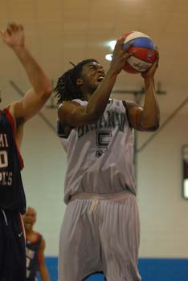v
Alex Hill 6’6 225 lbs G/F
World Basketball Association (WBA)
Team: Florida Flight

Strengths: A very unorthodox style of play allows Hill to be effective and very difficult to contain. Has a solid herky jerk style handle, with tricky hesitation moves going to the basket. He is a south paw lefty, and that asset makes him a natural scorer....... whether it is jumpers, floaters, put backs, or what ever, he will score, and do it efficiently. More of a scorer than shooter, but makes a great deal of amount to keep the defense honest. Shows a scorer's mentality. Hill posses a none stop motor that frustrates a defense because when he does miss a shot at close range, he out hustles everyone for put backs.........great rebounder for his size........has the determination to out work his opponent. Quick burst and explosive leaper, who gets many dunks in transition and through the lane......., runs the court well. Very humble and quite leader on, and off the court. Solid work ethic with strong physique.

Weakness: Needs to be more vocal, and assertive to teammates. At times can be a little relaxed on defense, but does put in the effort to get stops for his team. Hill is use to being the main focal point of the offense, and needs to learn to pick his spots during the course of the game. A decent shooter, but needs to become a great shooter if he is to go to the next level, (which is the NBA).

Outlook: Hill has shown that he is a big time prospect, being a former ABA All Star, and playing overseas. In the near future, he should definitely have a shot of playing on a bigger stage such as Europe, the D-League, or even the NBA. The sky is the limit for him if he continues to work hard. Hill is using the WBA League to fine tune, and sharpen his game. Great upside

Comparison: Demarre Carroll (Memphis Grizzlies)

Player profile submitted by: SMWW, and Florida Flight Scout Monta Williams

