ADAM COURCHAINE (Oct 2008)

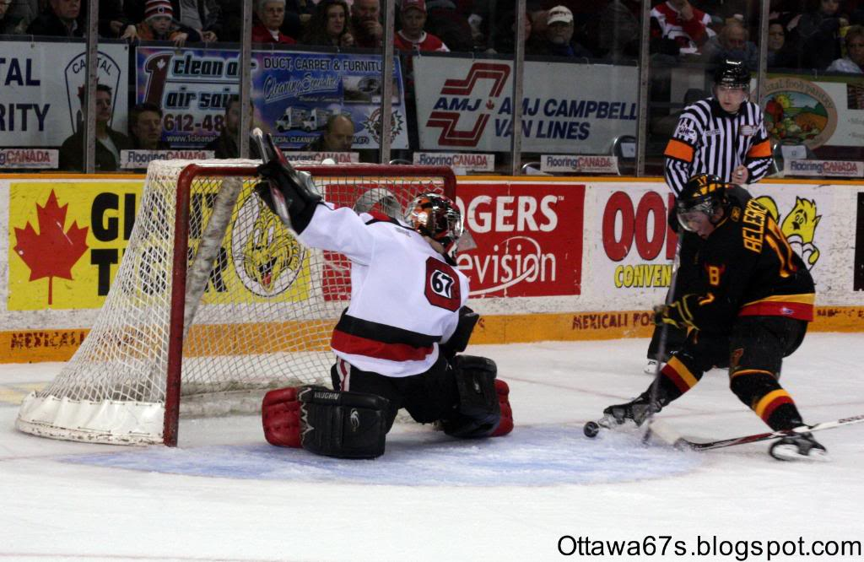
Photo courtesy of Blitzen Photography & Ottawa 67's Fan Blog

Team: Ottawa 67’s
League: Ontario Hockey League
Position: G
Born: 20 Feb 89
Height: 6.03
Weight: 185

Report Card – Excellent, Good, Average, Below Average, Poor

Size/Strength Excellent

Athleticism/Ability Good

Glove Excellent

Blocker Excellent

Lateral Movement Good

Positioning Good

Puckhandling Average

Hockey Sense Good

Poise Excellent

Strengths
1. Size
2. Poise
3. Quickness

Area’s For Improvement
1. Rebound control
2. Challenge the shooters more

Skill:
Butterfly style goaltender, with great size and great composure.

Scouting Report:
Courchaine is a butterfly style goaltender with a quick glove hand and an even better blocker. He has great size and is able to cover a lot of the net. While Courchaine has good positioning and is quick to react, he could work on being more aggressive when challenging the shooters. He moves well laterally. Courchaine has great poise and remains calm and focused during important games. He is working on his rebound control and puckhandling skills are improving since moving from a right to left-hand shot).

NHL Potential: Back-up goaltender, with more experience and improvement could become a late starting goaltender

Style compares to: Marc-Andre Fleury

Year | Team | GP | W | L | SO | GAA | PCT
07/08 | Ottawa 67’s (OHL) | 48 | 17 | 25 | 2 | 3.24 | 0.905
07/08 | Providence Bruins (AHL) | 59 | 2 | 0 | 0 | 1.67 | 0.920
08/09 | Ottawa 67’s (OHL) | 2 | 0 | 2 | 0 | 5.40 | 0.833
Bottom of Form
*08/09 stats as of Oct 13/08 @ 11:59pm

