LOGAN COUTURE (Oct 2008)

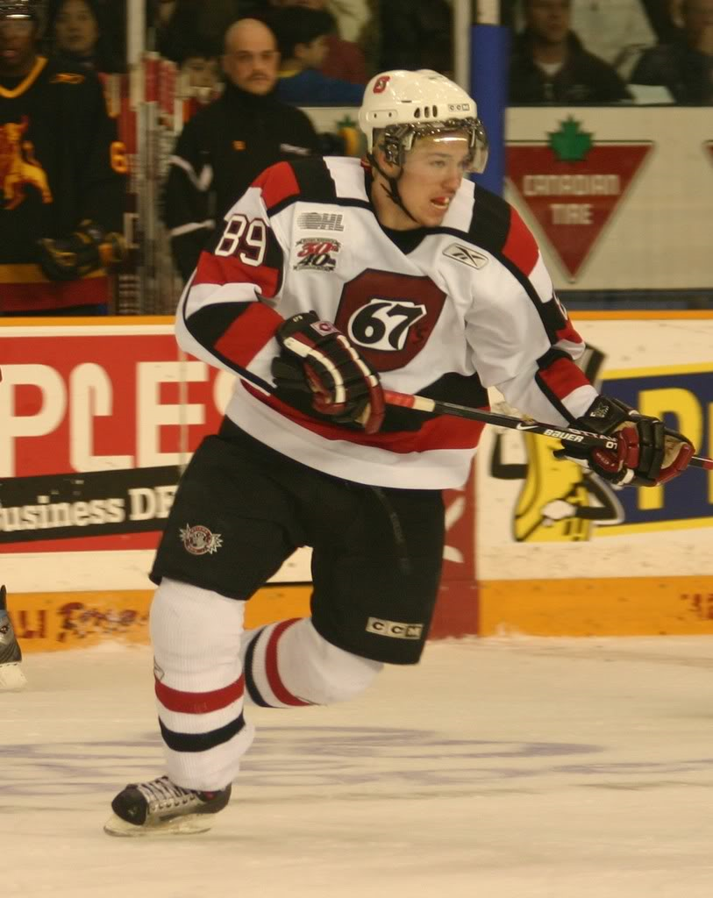
Photo courtesy of Blitzen Photography & Ottawa 67's Fan Blog

Team: Ottawa 67’s
League: Ontario Hockey League
Position: C
Born: 28 Mar 89
Height: 6.00
Weight: 192

Report Card – Excellent, Good, Average, Below Average, Poor

Size/Strength Good

Skating Good

Shot/Scoring Excellent

Puckhandling Excellent

Physical Play Good
Offensive Play Excellent
Defensive Play Good
Hockey Sense Excellent
Competitiveness Excellent

Strengths
1. Leadership
2. Hockey sense
3. Puck control

Area’s For Improvement
1. Acceleration
2. Overall strength

Skill:
Sound two-way centre with great hockey smarts and great puck control. Able to be an offensive threat while being defensively responsible.

Scouting Report:
Couture is a solid two-way centre with a great offensive upside. He has great hockey sense and is the type of player who makes those around him better. Couture has a great work ethic and is an obvious leader on his current team. He does not have perfect size, but isn’t afraid to block shots and sacrifice his body to create plays. Couture is comfortable in his own end as well as the opposition’s end. He is a decent skater, but has poor acceleration and can improve by getting quicker on his feet.

NHL Potential: 1-2nd line centre, versatile player

Style compares to: Rod Brind’Amour, Steve Yzerman, Michael Peca

Year | Team | GP | G | A | PTS | PIM
05/06 | Ottawa 67’s (OHL) | 65 | 25 | 39 | 64 | 52
06/07 | Ottawa 67’s (OHL) | 54 | 26 | 52 | 78 | 24
07/08 | Ottawa 67’s (OHL) | 51 | 21 | 37 | 58 | 37
08/09 | Ottawa 67’s (OHL) | 5 | 2 | 2 | 4 | 8
Bottom of Form
*08/09 stats as of Oct 13/08 @ 11:59pm

