TYLER CUMA (Oct 2008)

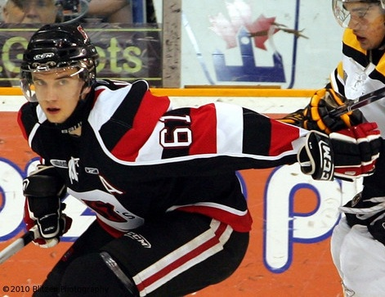
Photo courtesy of Blitzen Photography & Ottawa 67's Fan Blog

Team: Ottawa 67’s
League: Ontario Hockey League
Position: D
Born: 19 Jan 90
Height: 6.01
Weight: 190

Report Card – Excellent, Good, Average, Below Average, Poor

Size/Strength Average

Skating Excellent

Shot/Scoring Good

Puckhandling Excellent

Physical Play Average
Offensive Play Good
Defensive Play Good
Hockey Sense Excellent
Competitiveness Good

Strengths
1. Skating
2. Puck control
3. Hockey Sense

Area’s For Improvement
1. Needs to bulk up and add some muscle
2. Gap control

Skill:
Reliable two-way defenseman, who is a strong skater, with excellent great hockey sense and great puckhandling skills.

Scouting Report:
Cuma is a reliable two-way defenseman who is able to contribute to both ends of the rink. He is a strong skater and has the ability to move the puck up the ice and quarter back a power play. Cuma has great offensive instincts without sacrificing coverage in his own zone. He has great vision, an excellent hockey sense and a great work ethic. Although not afraid to rough it up, with his small stature, Cuma is easy to knock off the puck. He has started to already bulk up since originally drafted and has some more time over the next couple seasons.

NHL Potential: 1st-3rd defenseman. Power play quarterback.

Style compares to: Brian Campbell

Year | Team | GP | G | A | PTS | PIM
06/07 | Ottawa 67’s (OHL) | 63 | 3 | 16 | 19 | 55
07/08 | Ottawa 67’s (OHL) | 59 | 4 | 28 | 32 | 69
08/09 | Ottawa 67’s (OHL) | 5 | 0 | 1 | 1 | 4
Bottom of Form
*08/09 stats as of Oct 13/08 @ 11:59pm

