

Match Report On: Gainsborough Trinity F.C
Corby Town Vs Gainsborough Trinity
3rd December 2012
HT: 0-1
FT: 1-3
Scorers: Jonathan Williams, Ryan Kendall, Leon Mettam
Weather: Dry & Sunny
Ref: Andy Hendley
Pitch Conditions: Dry & Good playing surface,
Scout: Andy Main

Team Shape (Names & Numbers):
- Kenny Arthur
- Dominic Roma
- Kevin Sandwith
- Gavin Cowan (Capt)
- Luke Waterfall
- Jonathan Williams
- Jonathon D’Laryea
- Ryan Williams
- Ryan Kendall
- Paul Connor
- Lee Ridley
Subs:
- Jamie Yates
- Michael Leary (Sub Ryan Kendell)
- Darryn Stamp
- Leon Mettam
- Andrew Boyce (Sub Paul Connor)

Formation 4-4-2
1
2 5 4 11

8 7 6 3

10 9

Goalkeeper:
Kenny Arthur – Is a tall goalkeeper with good stature, He is confident on crosses, he tends to punch in a pressures situation getting good distance and height. His weaknesses can be with low driven crosses into the box which the back four are also uncomfortable with. He is strong on any high aerial ball into the box with confidence to come and claim.
He does not look to throw the ball out at any time; his main use of distribution is a drop kick direct and forward centrally to the NO. 10. He used this every time he had the ball in his hands. From goal kicks off the floor he also looked to his centrally to the NO.10.
No players looked to receive off the goalkeeper at any time, they would go high and phase one would be the central ball from Kenny to the number 10.
He has a good length on his drop kick hitting 20 yards over the half way line it is also very driven and accurate. His length off his goal kick is also past the half way line.
Defence:
They play with a back four. They tend to play a little deeper than normal due to the lack of pace that the two centre halves have. At no point did they attempt to push out quickly and were quite conservative about keeping the line slightly deeper.
The two central defenders may suffer from a small lack of pace but were rarely exposed; the aerial threat of them both and in particular the captain was outstanding. Any ball that was played high in a central area was always comfortably dealt with by both central defenders. Any ball that was played deeper in behind the goalkeeper was able to sweep.
Both full backs were instructed when they get the ball to hit long and deep into channels which both ran the channels very well. When the full backs received the ball inside there half they would hit the channels early and deep for the forwards.

Midfield:
The midfield four are very narrow. Both wingers will come inside at every opportunity meaning the width comes from the full backs. The crosses that Trinity created came from full backs pushing on. When the ball was in the oppositions half the midfield would look to play into the forwards feet as early as possible, who would look to set back to the central midfield player, who with the two wingers coming inside created the space for the full backs to push on and receive into crossing situations.
No 3. Is a more natural winger who is comfortable at running at players when asked, the number 8, naturally comes inside at every opportunity which caused an over load on Corby’s central midfield players.
With the wide players coming inside it caused all midfield players to have interchange positions often meaning no.7 would end up on the wide right. All players in the midfield looked comfortable with this position exchanges.
The pace comes from the left hand side No.3 and No. 11 cause many over lapping situations and crossing opportunities with the left back No. 11 looking very dangerous when going forward.
The narrowness off their midfield can caused problems with Corby as they always looked out numbered in central midfield.
Attack:
They are a very direct side and both forwards have a lot to offer when going forwards in context of their game plan.
Number 10 is a tall player and is their main point of attack; they will look to hit him at every opportunity from the Goalkeeper. When in the oppositions half they would look also look for his feet where he was also very comfortable to receive.
Number 9, was a smaller player who would always look to back in to gain a free kick, he looked comfortable to receive the ball to feet and would play on the last man when the ball has come from deep to the big aerial threat of the number 10.
They do not build play from the back they look to get the ball forward as quickly as possible in phase one, phase two is picked up by the central midfield players where there point of attack is to try get the ball wide to a full back that has push on into the final third or release the number 9 who will play on the last shoulder who is centre forward with pace.
Both forwards are happy to run the channels, very often they would try and gain a foul. If not the ball is set back to the full back where the point of attack will be changed through the central midfield player number 7, who was always comfortable to receive.
General
They are a direct organised and rugged team who would be very happy to play teams who are willing for a physical battle. They are not a passing team, they look to get the ball forward as quickly as possible and hit the front men as quickly as possible.
They do not press high they are happy to force the ball to the opposition full backs where they shape to force them long as they are confident of winning any high ball played forward down their throat.
It is key that no unnecessary free kicks and corners are given away. For all indirect free kicks in any area and corners both central defenders would go forward, A high ball would then be played into the box which caused problems for Corby all game. Direct free kicks in a dangerous would also need to be avoided when possible as they have No.3 and No.6 who look comfortable in striking the dead ball. Gainsborough’s first goal coming from a direct free kick.
A strong feature of the second goal was finding the No.10 feet who set back to a midfield player who they played an early through ball to the No. 9 who has peeled off and run the blind side of the central defender who smashed home in the one on one situation.
Goal’s numbers one and two came from a result of their game plan and what the patterns they shown in the first half. They look to gain free kicks in various areas of the pitch which gives them more opportunities to get the ball forward.
The goal against came from a burst of pace from Corby’s Jordan Spruce on Trinity’s No. 2 this is where you are able to un settle them, pace in wide areas and players that are willing to run at full backs. They didn’t look comfortable when Corby made substitutes which consisted of nothing but pace. When these players were running at the back four and in particular on the Right full back No. 2 this is when they were at their most vulnerable all game. They then changed to a 4-5-1 to see out the game which then caused Corby to push on they then scored a third from a breakaway long ball which Corby’s keeper miss judged leaving an empty net for No.15 to score. No.15 was also comfortable with the ball played into feet and running the channels.
No 7 has the most touches of the ball in Gainsborough’s midfield, after the knock down from the direct ball he would often receive the ball and be the player setting wide to the full backs.
The two left footed players are the No.11 and No. 3
Att Corners:
No 6 and 3 would take the corners; they varied the in swinging and out swinging had no particular routine but would aim for the penalty spot the majority of the time in order to give them the best chance to hit the central defenders no 7 and No. 10 who had the main aerial threat.
This was they tried to do from corners from both left and right.
Main Threats in the air. 4, 5, 7, 10
No 9 would sit on the goal keeper to cause confusion and obstruction.

Direct Set Plays:
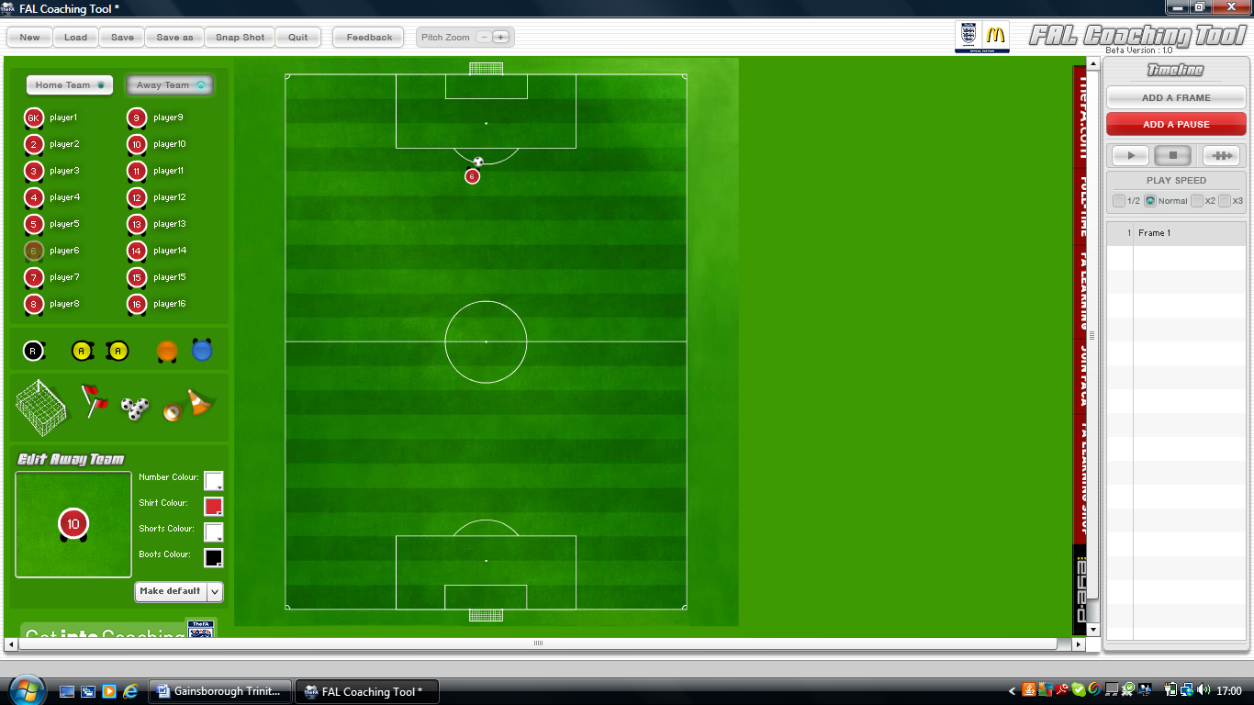
No 6 goal came from a direct free kick from a central area; a good strike hit medium height with power onto the post and in. Free kicks in dangerous areas should be avoided. No 6. has a great ability from dead ball situations.

Long Throws & Penalty’s
n/a
Tactical Weaknesses and Strengths:
When in control and in balanced they look comfortable and difficult to break down. However when out of balanced and faced with counter attacks against them they look vulnerable and uncomfortable with dealing with pace on the back foot.
When Corby got on top of the game and introduced substitutes with pace they then began to drop deeper and deeper and invited pressure on, they then gave away a lot of corners and didn’t look as comfortable with the pace. They then reverted to a 4-5-1 which turned into a 4-1-4-1 to see out the last 10 minutes. They conceded 9 corners in the second half.
A potential weakness can be played onto Trinity’s right back he can look vulnerable when faced with pace and when on the back foot.
To try and stop the supply to the forwards feet would be a chance to really stop the forefront of their attacks.
The two forwards must be playing well and in particular the number 10 if the game plan is to be successful which is was, and No.10 was their most influential player he lead the line well and help and set very well.
They are a better side down the left when going forward in wide areas.
Set Pieces:
Att:
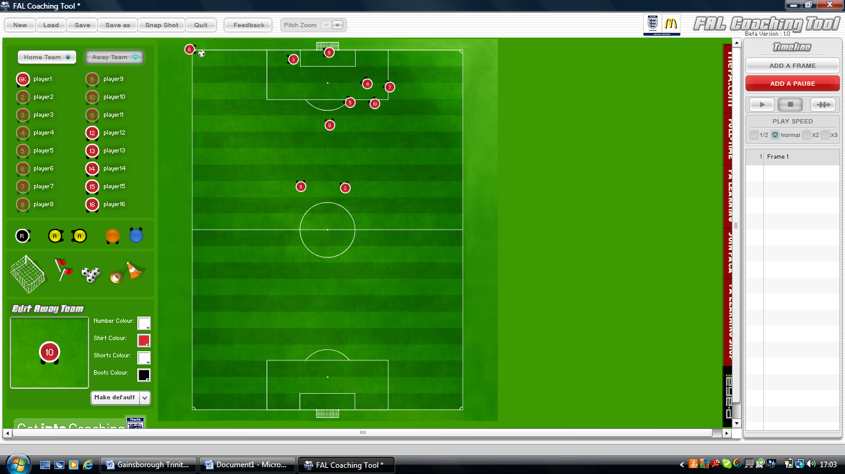

They continued to use this set up for the attacking Corners. Will the taller bodies starting at the back of the 18 yard and the deliver always around the penalty spot with the four big aerial threats attacking the ball. They did not opt for any change in style of corner and it was the same set up from the opposite side except No.6 and No.3 would have a role reversal. However they would not always swap.
Def:
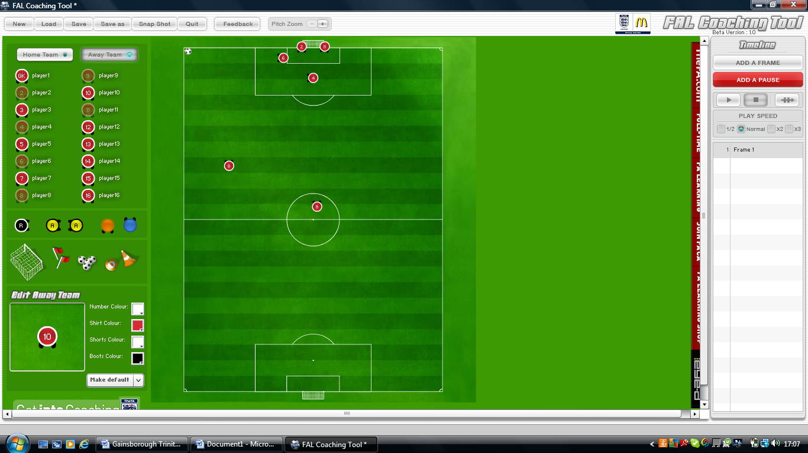
Everyone Else will Mark Man for Man. No 4 would take a position around the penalty spot but would continue to still mark. 8 would stay forward wide and 9 would stay forward centrally.
They would mark Man for Man on corners with a 6 yard blocker and the full backs on the posts.

They had no special moves or rehearsed clever set piece movements. On every in-direct free kick they would send all aerial threats forward as seen in the corner diagram and a ball would be played onto the penalty spot for the players to attack.

