Bryson Dunmeyer
BrysonDunmeyer@gmail.com
704-619-2905

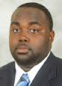

Professional: Eastern Kentucky Drillers (CIFL)
DL/OL
#69
2013 Season

HT: 6’2’’ WT:330lbs DL/OL DOB: 12/07/1989

Professional: Eastern Kentucky Drillers (CIFL) 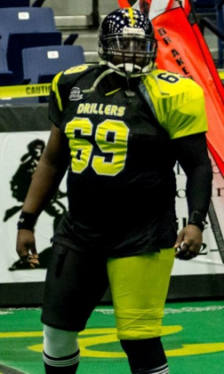
DL/OL
#69
2013 Season

College: Wake Forest University 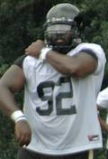
DL
#92
Class of 2012
2011 (Junior)
Played in two games off the bench ... Saw action against Gardner-Webb (Sept. 17) and Vanderbilt (Nov. 26).
2010 (Junior)
Earned his second varsity letter ... Saw action in the season opener against Presbyterian (Sept. 2).
2009 (Sophomore)
Earned his first varsity letter ... Saw action in Wake Forest's game against Elon on Sept. 19 ... Was on the travel squad for late season ACC games at Georgia Tech and at Duke.
2008 (Freshman)
Did not see any game action after joining the team in the fall as a walk-on.
High School
A 2008 graduate of North Mecklenburg High in Huntersville, N.C. ... Played for coach Glenn Padgett ... Collected 60 tackles and five sacks as a senior ... Finished fourth in the state in the discus in the 4A meet.
Personal
Majoring in history with minors in religion and sociology ... Son of Denetra Dunmeyer ... Born Dec. 7, 1989 ... Last name is pronounced "DUNN-my-er".

