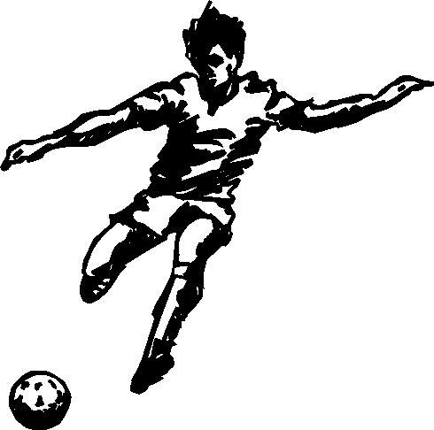THE SUMMIT SOCCER NETWORK
A WORLDWIDE SOCCER/FOOTBALL SCOUTING SERVICE

Edmund Owusu-Ansah

Top of Form
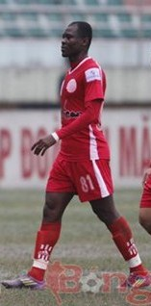
  Position : | Midfield
  Age : | 31
  Date of Birth : | April 2, 1983
  Birthplace : | Kumasi, Ghana.
  Nationality : | Ghanaian
  Height : | 1.78 m (5 feet 10 inches)
  Weight : | 165lbs/75kg
  Previous Club : | Vicem Hai Phong
  Leading Foot : | Right
  Profile
  Details
  Edmund Owusu-Ansah is a Ghamaian born football player. He is a midfielder who has often been touted as the “midfield general” for his command in midfield. He has the ability to exert energy in supporting offensive and defensive play.
  Career Highlights
  2013  2011 | Ghana Black Stars: West African Football Union Cup  Gold medalist.  Song Lam Nghe An : V-League Champions  2010— 2011 season  All time assist leader (18)  FA Cup Silver medallist  2010--2011
  2010  2009 | Hearts of Lions: 2010 MTN Top Four Tournament  Champions  Ghana Black Stars: 2009African Nations  Championship (CHAN)  Tournament Silver medalist.  West African Football  Union (WAFU) Bronze  medalist.
  2003-2007 | Kumasi Asante: 2007 Onetouch Gala  Kotoko Tournament Champions  2005 Confederations Cup  Silver Medalist  2005 Premier League  Champions  2005 Ogua Afahye Challenge  Cup Champions  2003/04 Coca Cola Four  Tournament Champions  2003/04 Premier League  Champions
  Playing Statistics
  Years Team Appearances Goals
  2013— Heart of Lions 10 3
  2011—2012 Vicem Hai Phong 25 4
  2010—2011 Song Lam Nghe An 33 4
  2007—2010 Heart of Lions 65 28
  2003—2007 Kumasi Asante Kotoko 123 24

General Information
Name | Edmund Owusu Ansah
Age | 31 | Height | 1.78m/5ft. 10inches
Weight | 165lbs/75kg | Position | Midfield
Club | Heart of Lions | Contract Expiry | N/A
Scout | E. Kwame Amoah | Date | February, 2014

Midfield
Ball Control | He has excellent close ball control and quick feet, retaining possession well, even when tightly marked. Controls and dribbles with both feet. He plays mostly with his head up, thus, the ability to see the bigger picture and make great plays.
Running with the ball | He confidently takes his man on and runs with the ball, has good pace to create space; and shows good composure and retention of the ball.
Attacking Ability | He is very attack minded, makes it a priority of distributing the ball to forwards. He looks to find spaces behind/in between the opposing team’s defense. He is also very quick to support the forward players, occasionally getting on and beyond the play.
Defending Ability | He is usually one of the first to retreat defensively. During counter attacks, he slows the breaking player with the ball down to allow defense to regroup. He is very confident in tussles in midfield
Heading | He is good with his head; vies for air balls, both offensively and defensively.
Tackling | Very aggressive when competing for the ball, he is mostly determined to win challenges, tending not to give up on plays.
Long Passing | Mostly designated as the “passer” playing right in front of the defense,  he makes it a priority of distributing the ball to initiate attacks. His ball passing has weight and pace.
Short Passing | Neat and tidy on the ball, he will play the short pass early and incisively. He mostly follows his passes always hungry for more of the ball, and as a support to other players.
Right Foot | A real strength, he is comfortable when he has the ball at his feet, showing good control and individual skills. He strikes the ball cleanly and manages to provide good feeds from passes, corners and free kicks.
Left Foot | Not his favorite foot but very potent when called to use.

Tactical Ability
Vision | He is a skilful player who makes the ball work with his passing abilities. He gets a good vision of the field by playing with his head up and by being aware of activities around him on the field. He sees supporting players, thus, sees the bigger picture. His movement off the ball is good, looking to follow passes, drop off and find space to receive and then make play.
Awareness
Movement Off The Ball
Athleticism
Pace | He has a little more than average pace but has a great “ball sense.” Great movements on and off the ball in support and in attack. Very competitive and fights vies for the ball. Very high work rate as he’s seen all over the field relentlessly defending and attacking. Average physique but tough in tussles.
Sharpness
Mobility
Body Strength
Workmate
Character
Efforts To Win Ball Back | Does not give up on plays, commits to winning balls.  Imposes himself in challenges.  Has a lot of ball sense—makes the ball work.  Seems to have two hearts with all the running.  Effective communication on the field, encourages and supports other players.  Very effective team player
Bravery - Physical
Bravery - Mental
Energetic
Leadership
Talkative
Competitive
Team Player

Assessment
Comments
His movement on and off the ball is of a high quality. Impresses as a “utility” player, able to cover many positions. He possesses some good touches, skilled but not about showmanship. He is very effectual in distributing balls from central midfield and can be a force when attacking. His passes 70 out of 100 will find a man. He has a great on field vision and aware of his surroundings, confident in his fellow players.
Recommendation
Without questions and doubt, a very skilful and talented soccer player who has excellent ball sense, control and passing ability. He backs it up with a high work rate and would be a great addition to any team seeking to boost their squad with a versatile player

Leading the National Team Against Argentina
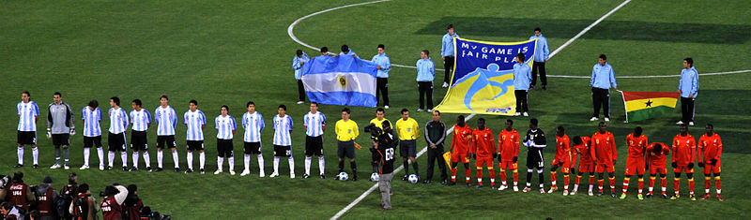

Leading the National Team at the CHAN Tournament 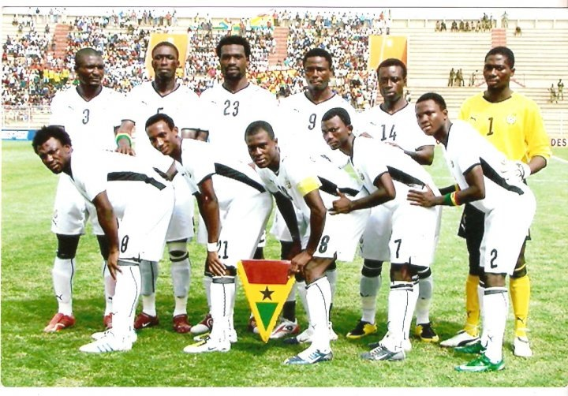
Snapshots
