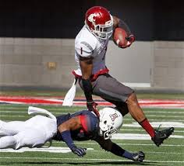
Vince Mayle
WR
Washington State
6’2” 224 lbs

Strengths | Weaknesses | Combine results
Prototype size | Limited Route tree | 40 yd dash- 4.52
Hands catcher | Struggles to separate | Vertical jump- 35.5 inches
YAC ability | Drops (focus) | Broad jump- 117 inches
High ceiling | Still learning the position | 3 cone- 6.93
Wins with size |  | 20 yd shuttle- 4.13

Games watched: Washington 2014, Rutgers 2014, Utah 2014, Oregon 2014
Summary: Vince Mayle has the size that you look for in a WR. As a former Basketball player he knows how to position himself and box CBs out. When he has the ball in his hands he is physical and fights for that extra yard. He also shows the ability to break for long runs and take it to the house. With all that said, Vince is limited by his struggle to separate from CBs and his drops (13 drops in 2014). He will need to learn the full route tree because at Washington State he only ran the fade, slant, smoke, and drag routes. However, with those 4 routes he caught 106 balls and gained 1,483 receiving yards so the talent is there waiting to be nurtured. If he can get a solid offseason under his belt he will contribute to a team in his sophomore year.
Scheme Fit: West Coast/ Spread
Comparison: Jarrett Boykin
Projected Round: 5th round
Best Fits: San Diego Chargers, New Orleans Saints, Detroit Lions, Arizona Cardinals

