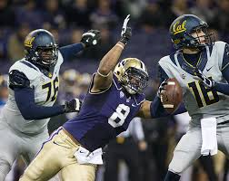
Hau’oli Kikaha
LB
Washington
6’2” 253 lbs.

Strengths | Weaknesses | Combine results
Quick off of the edge | Tore ACL twice (2011) (2012) | 40 yd dash- 4.9
Speed rusher | Washed up in run game | Vertical jump- 34.5 inches
Bend around the corner to attack the QB | Setting the edge in the run game | Broad jump- 112 inches
Hand usage | coverage | 20 yd shuttle- 4.33
disciplined | Playing strength | Bench- 20
Consistent motor |  | 3 cone drill- 7.13

Games watched: Hawaii 2014, California 2014, and Stanford 2014
Summary: Hau’oli Kikaha dominated his senior season by amassing 19 sacks on a loaded Washington Huskies squad. Kikaha is quick off of the edge and uses his hands well to disengage from tackles and attack the QB. His quickness is only challenged by his all-out motor that allows him to bring himself back into a play that he was taken out of. Although Kikaha has experience playing as a DE and an OLB, his best fit is in a 3-4 defense playing a pass rushing OLB. He struggles in run support and gets moved out of the play, so strength is an issue. He has some coverage ability but is inconsistent because of his lack of experience doing it. However, the biggest issue will be his surgically repaired knee. He tore the same knee twice in back to back season, 2011 & 2012, however he seems fully healthy and ready to terrorize QBs in the NFL.

Scheme Fit: 3-4 OLB
Comparison: Osi Umenyiora
Projected Round: 3rd round
Best Fits: San Diego Chargers, NY Jets, Arizona Cardinals, Philadelphia Eagles

