NetScouts Player Evaluation
Date: December 29, 2012 | Game: UNC vs. UNLV | Scout: Leon W. Dillard

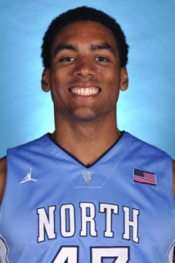
Player/Number: James McAdoo (#43) | Height: 6’9”
School: University of North Carolina | Weight: 230
Class: 2015 | Position: Forward

Athleticism/Body: Athletic build, but needs to improve strength. Good speed running the floor and with his first step off the dribble. Average lateral speed and quickness defensively. Most effective attacking basket and in transition.
Shooting: Solid form on stroke with ability to score 15’ in. Needs to improve range on shot to be more consistent from 15’ to 18’ which will make him more of a threat. Average mid-range game with quick release on his shot and proper footwork. Decent FT shooter at 62%.
Position Offense: Fundamentally sound player who’s most effective when playing active and in isolation type situations. Can play with his back to the basket coupled with good footwork allowing him to elevate over defenders for his shot. Attacks the basket in penetration with a quick first step allowing him to draw contact and get to the FT line.
Defense/Rebounding: Smart defender with average foot speed and lateral quickness. Pretty good playing the passing lanes for steals. Decent job defending 1on1, but needs to get stonger to effectively defend in the post. Average on the boards as he averages 8.3 rebounds per game.
Miscellaneous: A smart player with a good basketball IQ. Possesses a winning mentality, positive attitude and developing well. Needs to get stronger and play more aggressive.
Overall Rating: A good player that will be a NBA 1st round pick in the future. Will benefit by finishing his next two years of college.

