Stephen Curry
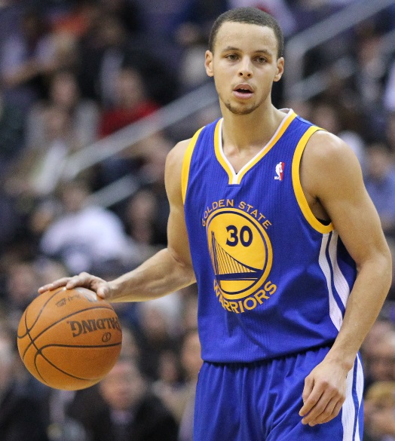

Birthday: March 14, 1988
Height : 6’3:
Weight: 185 lbs
College: Davidson
Drafted: Golden State Warriors/ 1st round 2009/ 7th overall pick
2013–14 | Golden State | 50 | 50 | 37.7 | .463 | .415 | .868 | 4.4 | 9.0 | 1.7 | .2 | 24.6
Career |  | 308 | 302 | 35.7 | .465 | .439 | .893 | 4.1 | 6.6 | 1.7 | .2 | 20.0

SCORING
The easiest thing to say that can sum up Steph Curry is that he is the purest shooter in the league. But he is so much more than what most pure shooters of his stature are often given credit for. He is a very good ball handler, although I tend to feel he should operate away from the ball more often than he does. Curry is a great shooter period, but if he were not assuming the point guard responsibilities I think he would be an even better scorer.
Steph and his backcourt mate (Klay Thompson) are both second generation NBA products and no one can argue that as far as scoring goes they are one of the scariest duos in the league. In my opinion the Golden State Warriors should be looking to find a guard that can facilitate the offense.
This would allow Steph to focus on some shooting guard responsibilities and Klay Thompson will flourish along the perimeter at the small forward position.
Steph is a great one on one scorer. He is a rare breed of player that can score from anywhere on the floor and has the ability to create his own shot. He is averaging 24.6 points per game for 2013-14 season.

PASSING
Despite my earlier opinion that he should not be the primary ball handler he still manages to dish out 8.5 assists per game. This number is a nice figure to look at on paper but when we are talking about more than 2.5 turnovers per game this is where I start to question him as the primary ball handler. He will get the ball to his teammates but tends to turn the ball over often in the half-court offense.

DEFENSE
Steph is a blur on the court so he is valuable when it comes to getting turnovers. He can pick up a couple steals per game, but he still has room for quite a bit of improvement on defense. He tends to overplay the ball and lose his man. He often gets lost in traffic coming off screens. I think he could benefit from some of his own offensive film when it comes to improvement on defense, because his weaknesses on defense are exactly what he takes advantage of on offense.

OVERALL
A very dangerous scorer from anywhere within 25 feet. Ok 25 feet is a bit extravagant but you get the point. He will go down as one of the best shooters this league has seen as long as he stays healthy and stays around another 10 years. He already has set the single season record for 3 pointers made in a single season by making 272 3 point field goals.

